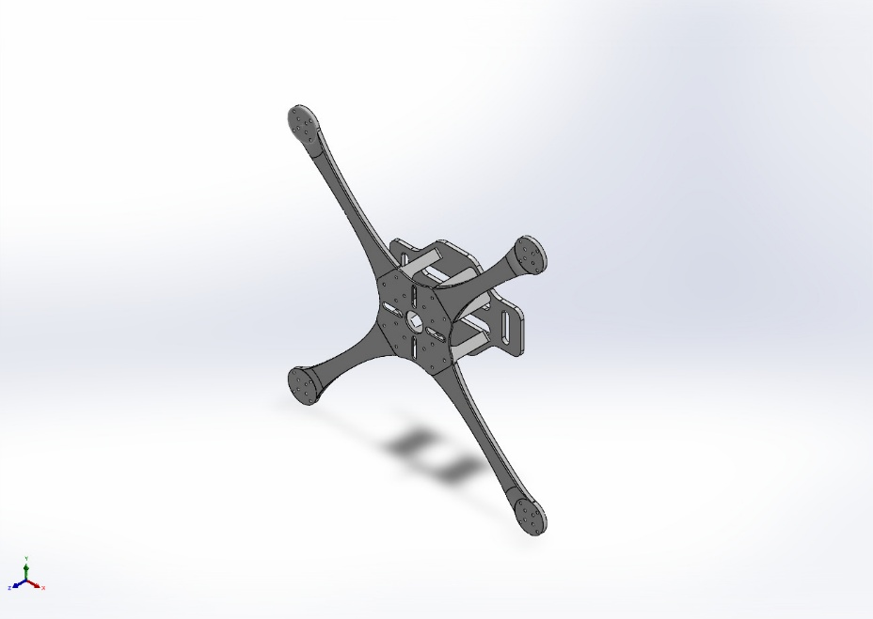 | Simulation of F450 Frame_GIT  Date: 03 June 2026  Designer: Solidworks  Study name: Hover  Analysis type: Static  Table of Contents  Description 1  Assumptions 2  Model Information 3  Study Properties 7  Units 7  Material Properties 8  Loads and Fixtures 9  Connector Definitions 10  Interaction Information 11  Mesh information 12  Sensor Details 16  Resultant Forces 17  Beams 17  Study Results 18  Conclusion 21

Description
No Data

Assumptions

Model Information

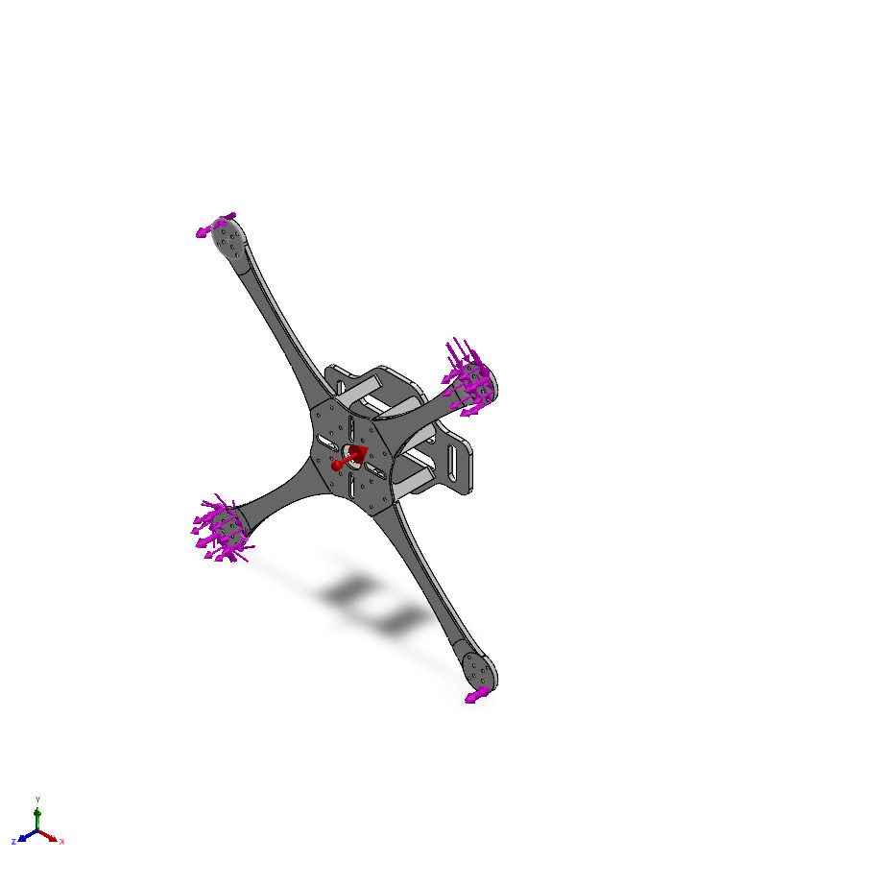
Model name: F450 Frame_GIT
Current Configuration: Default
Solid Bodies
Document Name and Reference | Treated As | Volumetric Properties | Document Path/Date Modified
Top[1]  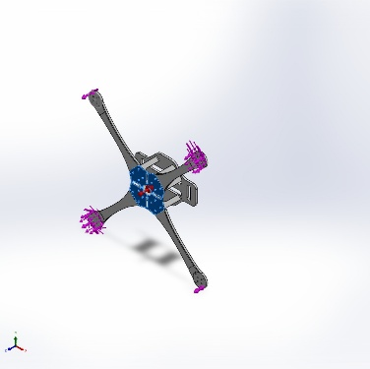 | Solid Body | Mass:0.0175184 kg  Volume:1.5367e-05 m^3  Density:1,140 kg/m^3  Weight:0.17168 N | C:\Users\asus\Documents\Solidworks assignments\Chair\F450\F450 Frame_GIT.SLDPRT  Jun 3 16:02:15 2026
Base[1]  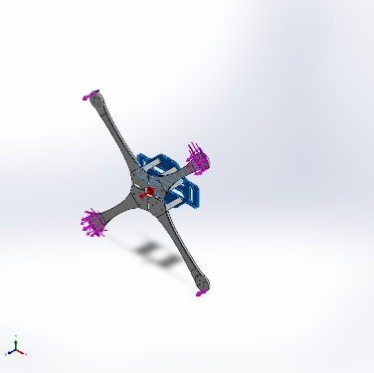 | Solid Body | Mass:0.0652374 kg  Volume:5.72258e-05 m^3  Density:1,140 kg/m^3  Weight:0.639326 N | C:\Users\asus\Documents\Solidworks assignments\Chair\F450\F450 Frame_GIT.SLDPRT  Jun 3 16:02:15 2026
Arm Top (1) (1)[1]  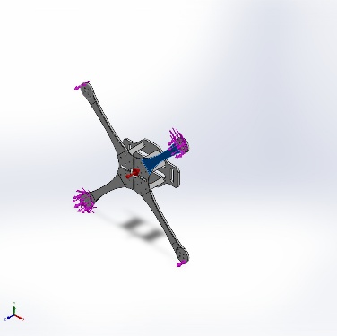 | Solid Body | Mass:0.00713681 kg  Volume:6.26125e-06 m^3  Density:1,139.84 kg/m^3  Weight:0.0699407 N | C:\Users\asus\Documents\Solidworks assignments\Chair\F450\F450 Frame_GIT.SLDPRT  Jun 3 16:02:15 2026
Arm (1) (1)[1]  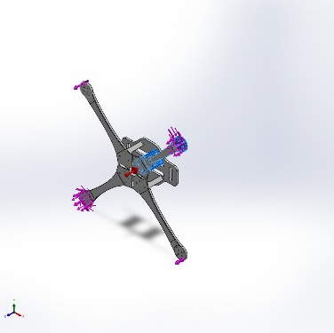 | Solid Body | Mass:0.0529117 kg  Volume:4.63948e-05 m^3  Density:1,140.46 kg/m^3  Weight:0.518534 N | C:\Users\asus\Documents\Solidworks assignments\Chair\F450\F450 Frame_GIT.SLDPRT  Jun 3 16:02:15 2026
Arm Top (2)[1]  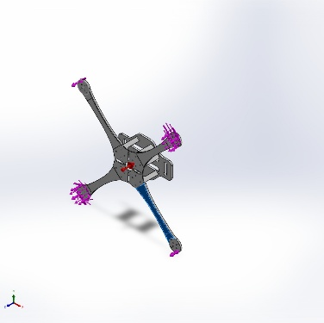 | Solid Body | Mass:0.00713792 kg  Volume:6.26164e-06 m^3  Density:1,139.94 kg/m^3  Weight:0.0699517 N | C:\Users\asus\Documents\Solidworks assignments\Chair\F450\F450 Frame_GIT.SLDPRT  Jun 3 16:02:15 2026
Arm (2)[1]  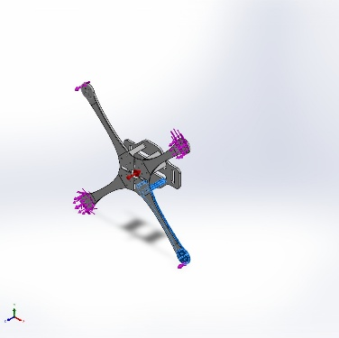 | Solid Body | Mass:0.0528642 kg  Volume:4.6364e-05 m^3  Density:1,140.2 kg/m^3  Weight:0.518069 N | C:\Users\asus\Documents\Solidworks assignments\Chair\F450\F450 Frame_GIT.SLDPRT  Jun 3 16:02:15 2026
Arm Top (1)[1]  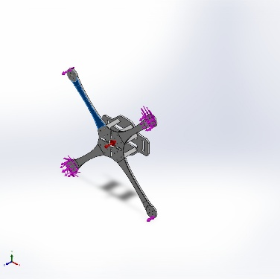 | Solid Body | Mass:0.00713792 kg  Volume:6.26164e-06 m^3  Density:1,139.94 kg/m^3  Weight:0.0699517 N | C:\Users\asus\Documents\Solidworks assignments\Chair\F450\F450 Frame_GIT.SLDPRT  Jun 3 16:02:15 2026
Arm (1)[1]  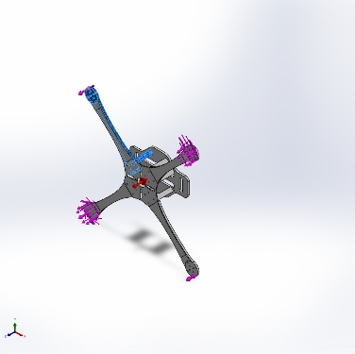 | Solid Body | Mass:0.0528642 kg  Volume:4.63952e-05 m^3  Density:1,139.43 kg/m^3  Weight:0.518069 N | C:\Users\asus\Documents\Solidworks assignments\Chair\F450\F450 Frame_GIT.SLDPRT  Jun 3 16:02:15 2026
Arm Top[1]  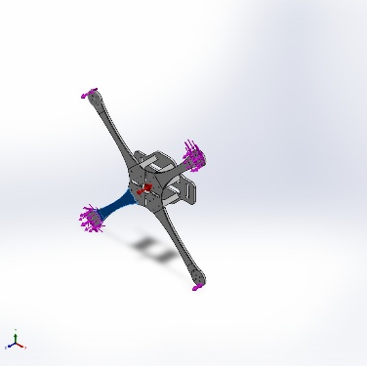 | Solid Body | Mass:0.00713681 kg  Volume:6.2604e-06 m^3  Density:1,139.99 kg/m^3  Weight:0.0699407 N | C:\Users\asus\Documents\Solidworks assignments\Chair\F450\F450 Frame_GIT.SLDPRT  Jun 3 16:02:15 2026
Arm [1]  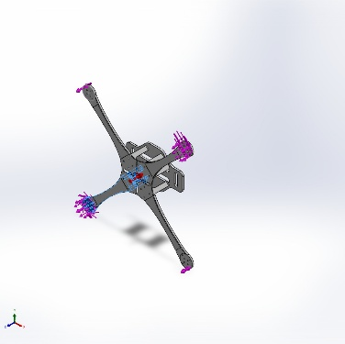 | Solid Body | Mass:0.0529117 kg  Volume:4.64235e-05 m^3  Density:1,139.76 kg/m^3  Weight:0.518534 N | C:\Users\asus\Documents\Solidworks assignments\Chair\F450\F450 Frame_GIT.SLDPRT  Jun 3 16:02:15 2026

Study Properties
Study name | Hover
Analysis type | Static
Mesh type | Solid Mesh
Thermal Effect: | On
Thermal option | Include temperature loads
Zero strain temperature | 298 Kelvin
Include fluid pressure effects from SOLIDWORKS Flow Simulation | Off
Solver type | Automatic
Inplane Effect: | Off
Soft Spring: | Off
Inertial Relief: | On
Incompatible bonding options | Automatic
Contact penalty stiffness scale factor | 1
Large displacement | Off
Compute free body forces | On
Friction | Off
Use Adaptive Method: | Off
Result folder | SOLIDWORKS document (C:\Users\asus\Documents\Solidworks assignments\Chair\F450)

Units
Unit system: | SI (MKS)
Length/Displacement | mm
Temperature | Kelvin
Angular velocity | Rad/sec
Pressure/Stress | N/m^2

Material Properties
Model Reference | Properties | Components
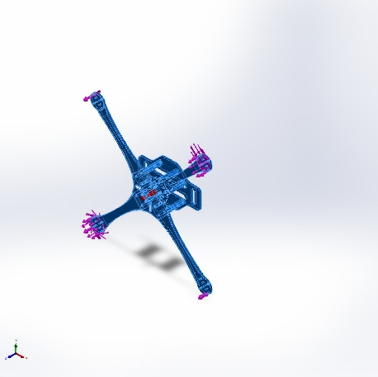 | Name: PA66  Model type: Linear Elastic Isotropic  Default failure criterion: Max von Mises Stress  Yield strength: 7.5e+07 N/m^2  Tensile strength: 8e+07 N/m^2  Compressive strength: 1.1e+08 N/m^2  Elastic modulus: 3.3e+09 N/m^2  Poisson's ratio: 0.394  Mass density: 1,140 kg/m^3  Shear modulus: 1.2e+09 N/m^2  Thermal expansion coefficient: 9e-05 /Kelvin | SolidBody 1(Top[1])(F450 Frame_GIT),  SolidBody 2(Base[1])(F450 Frame_GIT),  SolidBody 3(Arm Top (1) (1)[1])(F450 Frame_GIT),  SolidBody 4(Arm (1) (1)[1])(F450 Frame_GIT),  SolidBody 5(Arm Top (2)[1])(F450 Frame_GIT),  SolidBody 6(Arm (2)[1])(F450 Frame_GIT),  SolidBody 7(Arm Top (1)[1])(F450 Frame_GIT),  SolidBody 8(Arm (1)[1])(F450 Frame_GIT),  SolidBody 9(Arm Top[1])(F450 Frame_GIT),  SolidBody 10(Arm [1])(F450 Frame_GIT)
Curve Data:N/A

Loads and Fixtures

Load name | Load Image | Load Details
Gravity-1 | 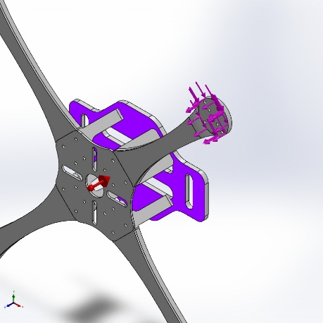 | Reference: Face< 1 >  Values: 0 0 9.81  Units: m/s^2
Distributed Mass-1 | 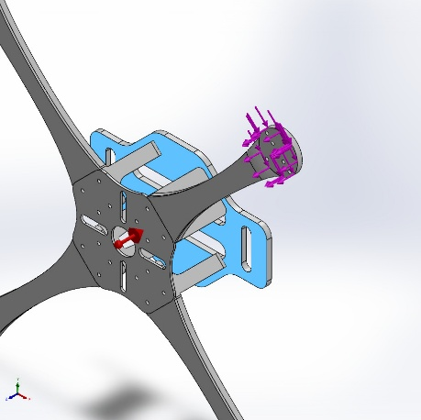 | Entities: 1 face(s)  Type: Displacement (Direct transfer)  Coordinate System: Global cartesian coordinates  Translation Values: ---, ---, --- mm  Rotation Values: ---, ---, --- deg  Reference coordinates: 0 0 0 mm  Remote Mass: 1.5 kg  Moment of Inertia: 0,0,0,0,0,0 kg.m^2  Components transferred: NA
Force-1 | 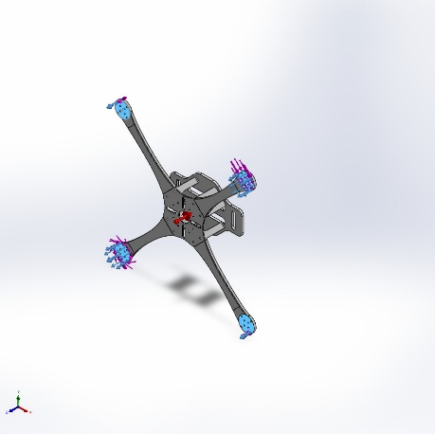 | Entities: 4 face(s)  Type: Apply normal force  Value: -10 N
Torque-1 | 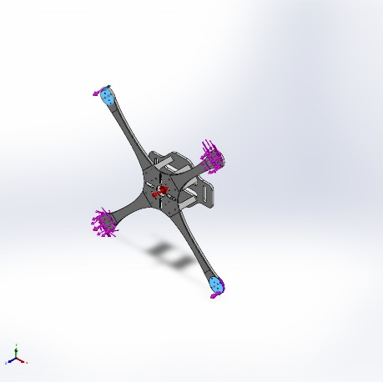 | Entities: 2 face(s)  Reference: Face< 1 >  Type: Apply torque  Value: 0.25 N.m
Torque-2 | 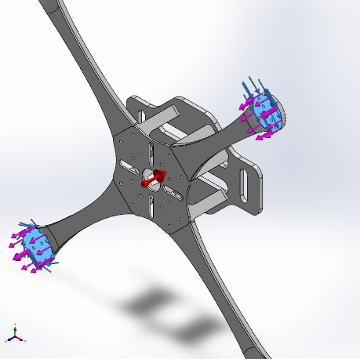 | Entities: 2 face(s)  Reference: Face< 1 >  Type: Apply torque  Value: 0.25 N.m

Connector Definitions
No Data

Interaction Information

Interaction | Interaction Image | Interaction Properties
Global Interaction | 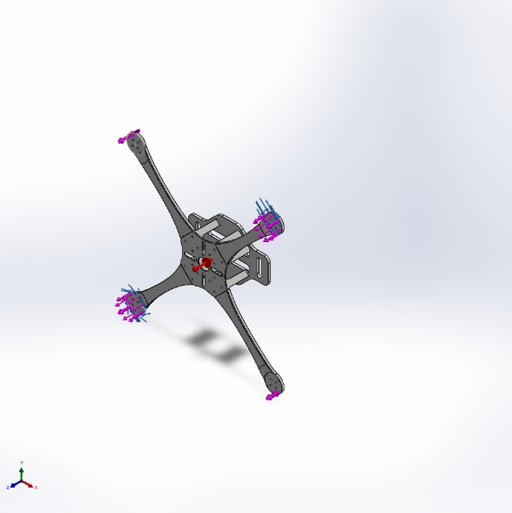 | Type: Bonded  Components: 1 component(s)  Options: Independent mesh

Mesh information
Mesh type | Solid Mesh
Mesher Used: | Blended curvature-based mesh
Jacobian points for High quality mesh | 16 Points
Maximum element size | 28.6846 mm
Minimum element size | 0.517638 mm
Mesh Quality | High

Mesh information - Details
Total Nodes | 816806
Total Elements | 512380
Maximum Aspect Ratio | 64.119
% of elements with Aspect Ratio < 3 | 99.7
Percentage of elements with Aspect Ratio > 10 | 0.00839
Percentage of distorted elements | 0
Time to complete mesh(hh;mm;ss): | 00:01:19
Computer name:

Mesh Control Information:
Mesh Control Name | Mesh Control Image | Mesh Control Details
Control-1 | 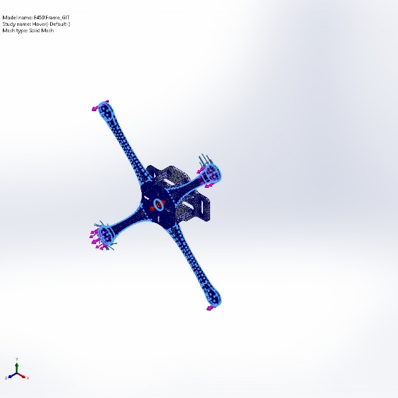 | Entities: 144 edge(s), 4 face(s)  Units: mm  Size: 1.4  Ratio: 1.4

Mesh Quality Plots
Name | Type | Min | Max
Quality1 | Aspect Ratio | 1.026  Element: 212881 | 64.119  Element: 174663
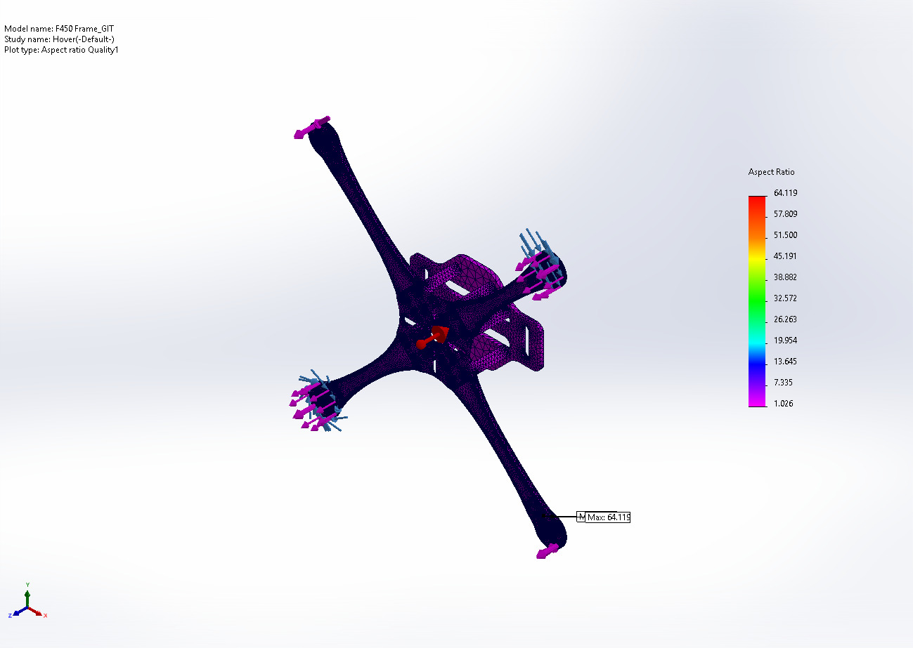
F450 Frame_GIT-Hover-Quality-Quality1

Name | Type | Min | Max
Diagnosis2 | Mesh Quality Diagnostics : Aspect Ratio | 1.026  Element: 212881 | 64.119  Element: 174663
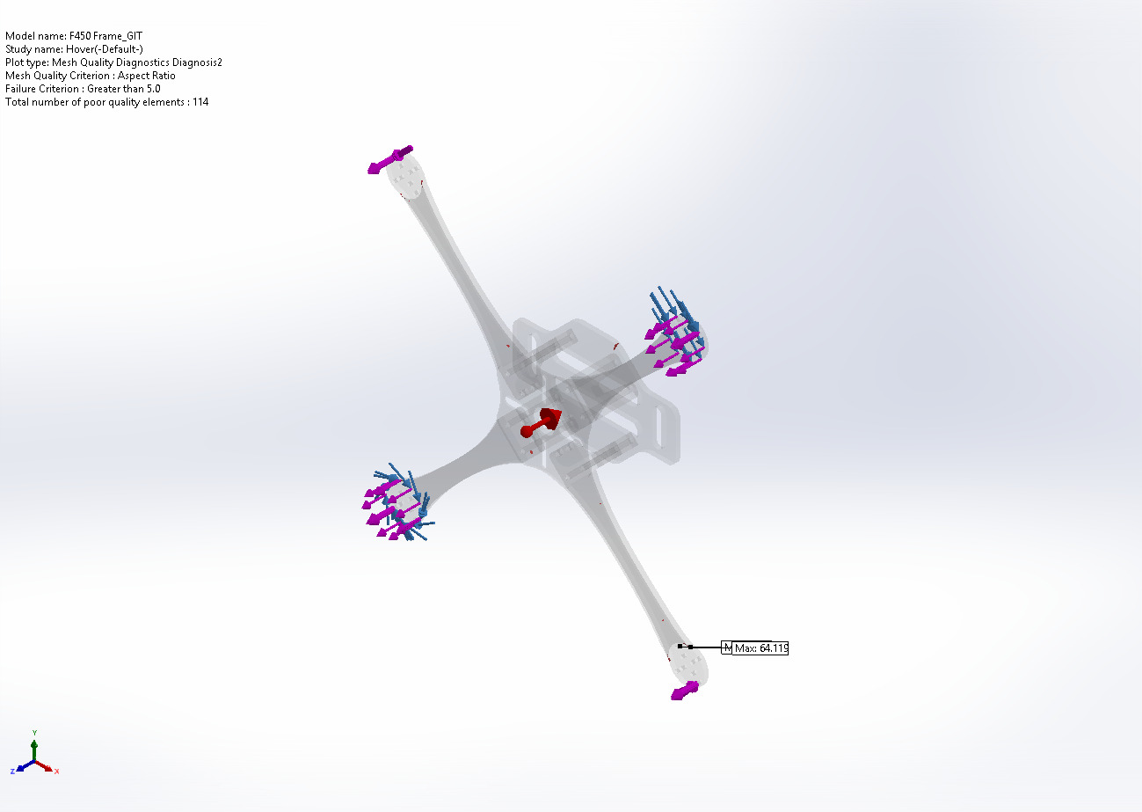
F450 Frame_GIT-Hover-Quality-Diagnosis2

Name | Type | Min | Max
Diagnosis3 | Mesh Quality Diagnostics : Jacobian ratio | 1.000  Element: 29 | 18.052  Element: 174663
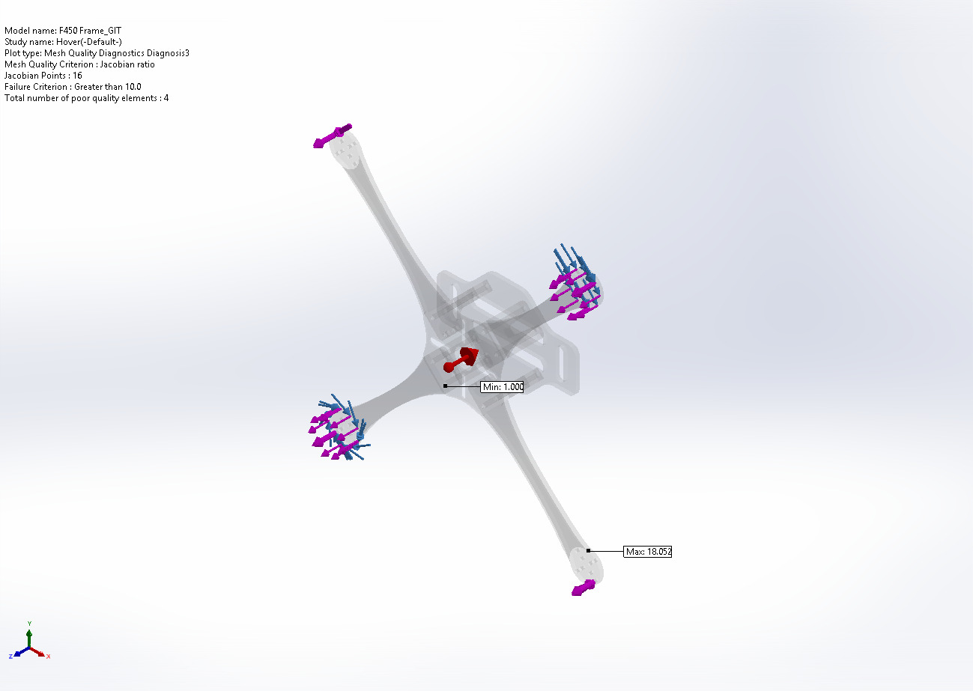
F450 Frame_GIT-Hover-Quality-Diagnosis3

Name | Type | Min | Max
Diagnosis4 | Mesh Quality Diagnostics : Element volume | 0.000  Element: 290569 | 0.000  Element: 49722
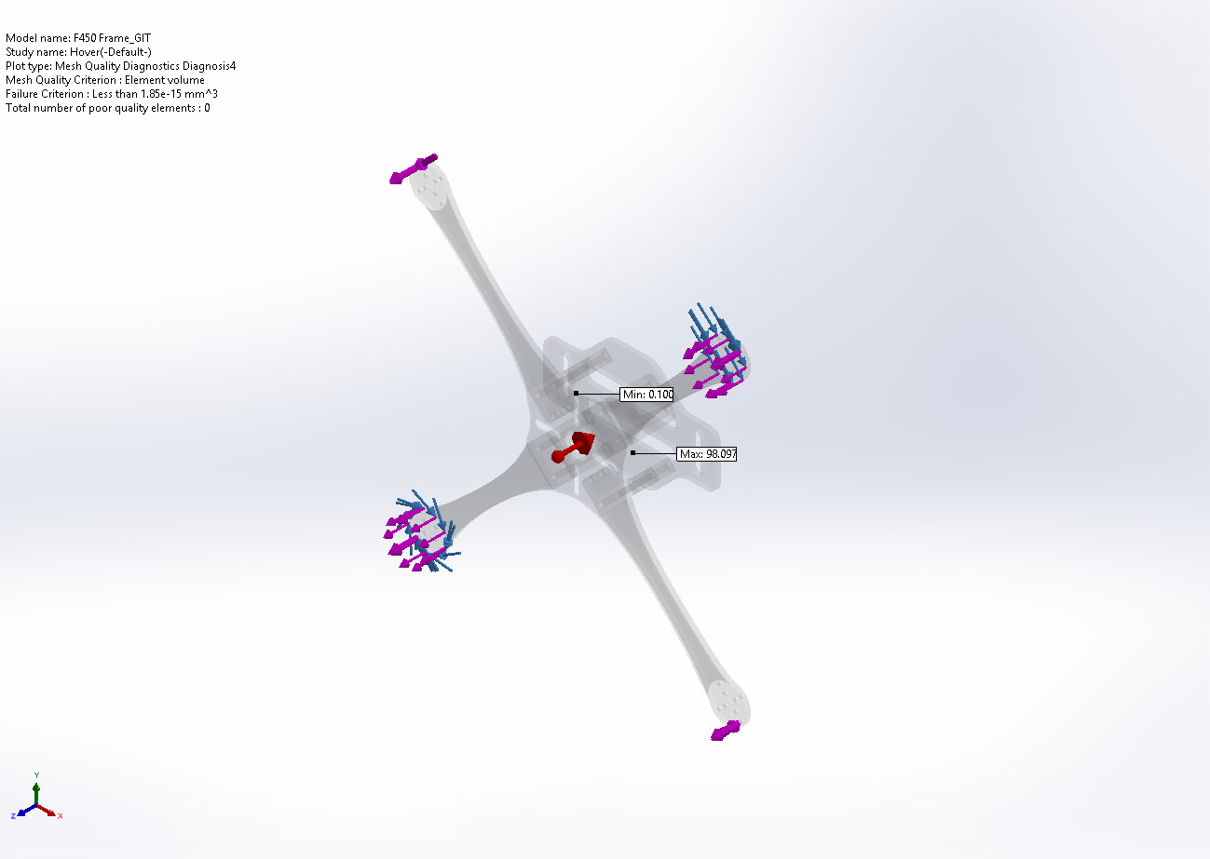
F450 Frame_GIT-Hover-Quality-Diagnosis4

Sensor Details
No Data

Resultant Forces

Reaction forces
Selection set | Units | Sum X | Sum Y | Sum Z | Resultant
Entire Model | N | 0 | 0 | 0 | 1e-33

Reaction Moments
Selection set | Units | Sum X | Sum Y | Sum Z | Resultant
Entire Model | N.m | 0 | 0 | 0 | 0

Free body forces
Selection set | Units | Sum X | Sum Y | Sum Z | Resultant
Entire Model | N | -0.00970188 | -0.0930738 | 4.77572 | 4.77664

Free body moments
Selection set | Units | Sum X | Sum Y | Sum Z | Resultant
Entire Model | N.m | 0 | 0 | 0 | 1e-33

Beams
No Data

Study Results

Name | Type | Min | Max
Stress1 | VON: von Mises Stress | 2,003.749N/m^2  Node: 93179 | 5,436,142.000N/m^2  Node: 293131
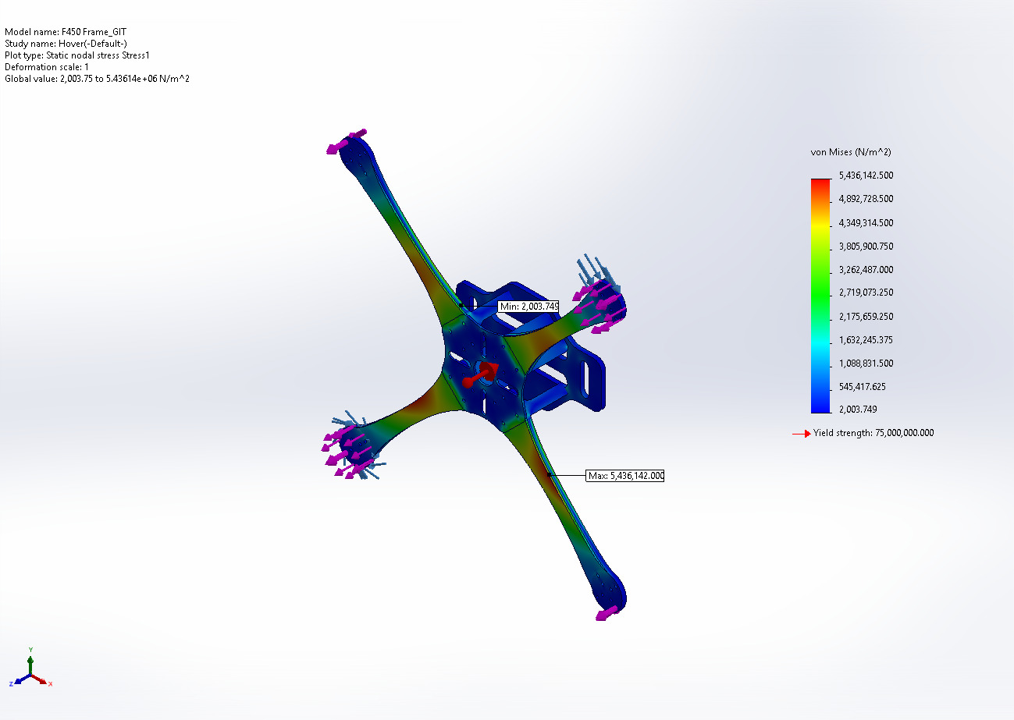
F450 Frame_GIT-Hover-Stress-Stress1

Name | Type | Min | Max
Displacement1 | URES: Resultant Displacement | 2.841e-02mm  Node: 217735 | 4.518e+00mm  Node: 479504
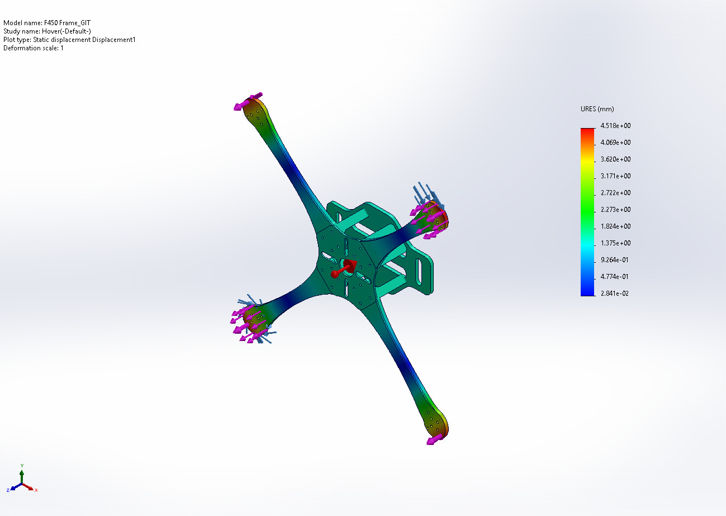
F450 Frame_GIT-Hover-Displacement-Displacement1

Name | Type | Min | Max
Strain1 | ESTRN: Equivalent Strain | 5.892e-07  Element: 50449 | 1.437e-03  Element: 400310
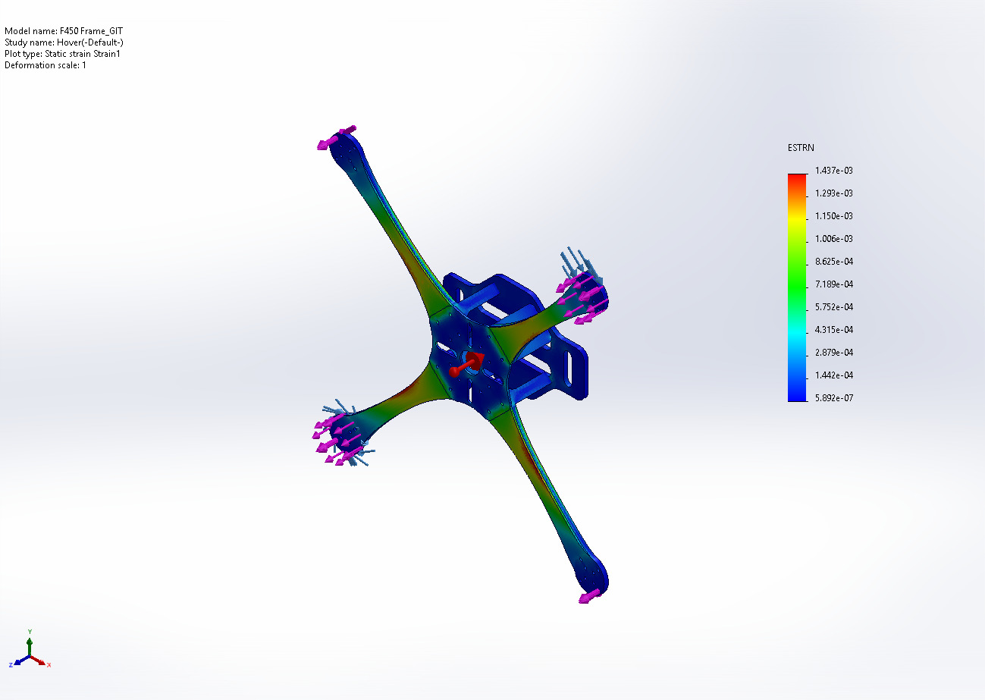
F450 Frame_GIT-Hover-Strain-Strain1

Name | Type
Design Insight1 | Design Insight
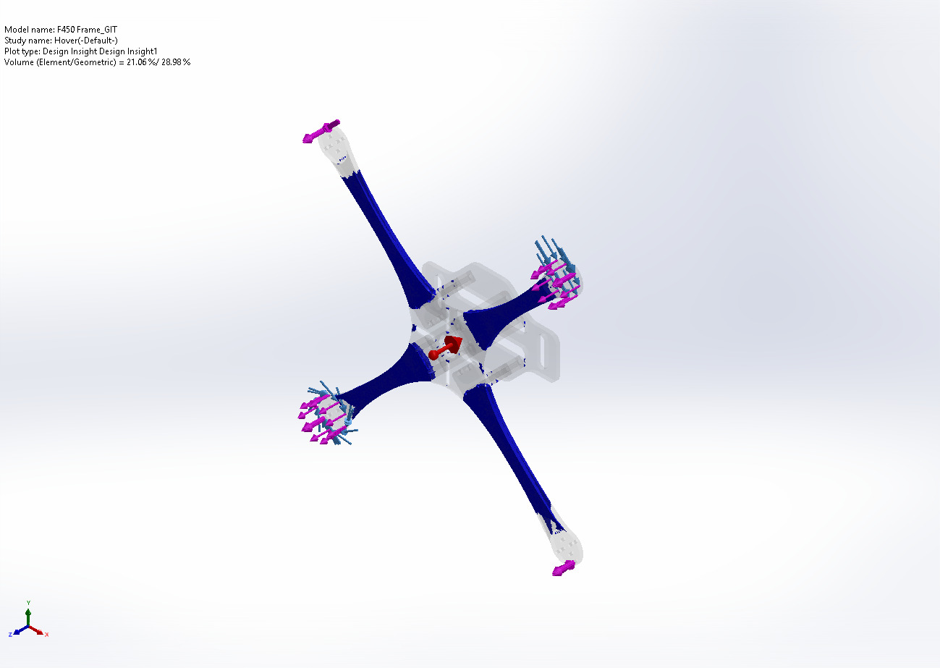
F450 Frame_GIT-Hover-Design Insight-Design Insight1

Conclusion

